Supporting Evidence Form – 129947 –Library Assistant – Radcliffe Camera and the WUL (Full-time, Permanent)
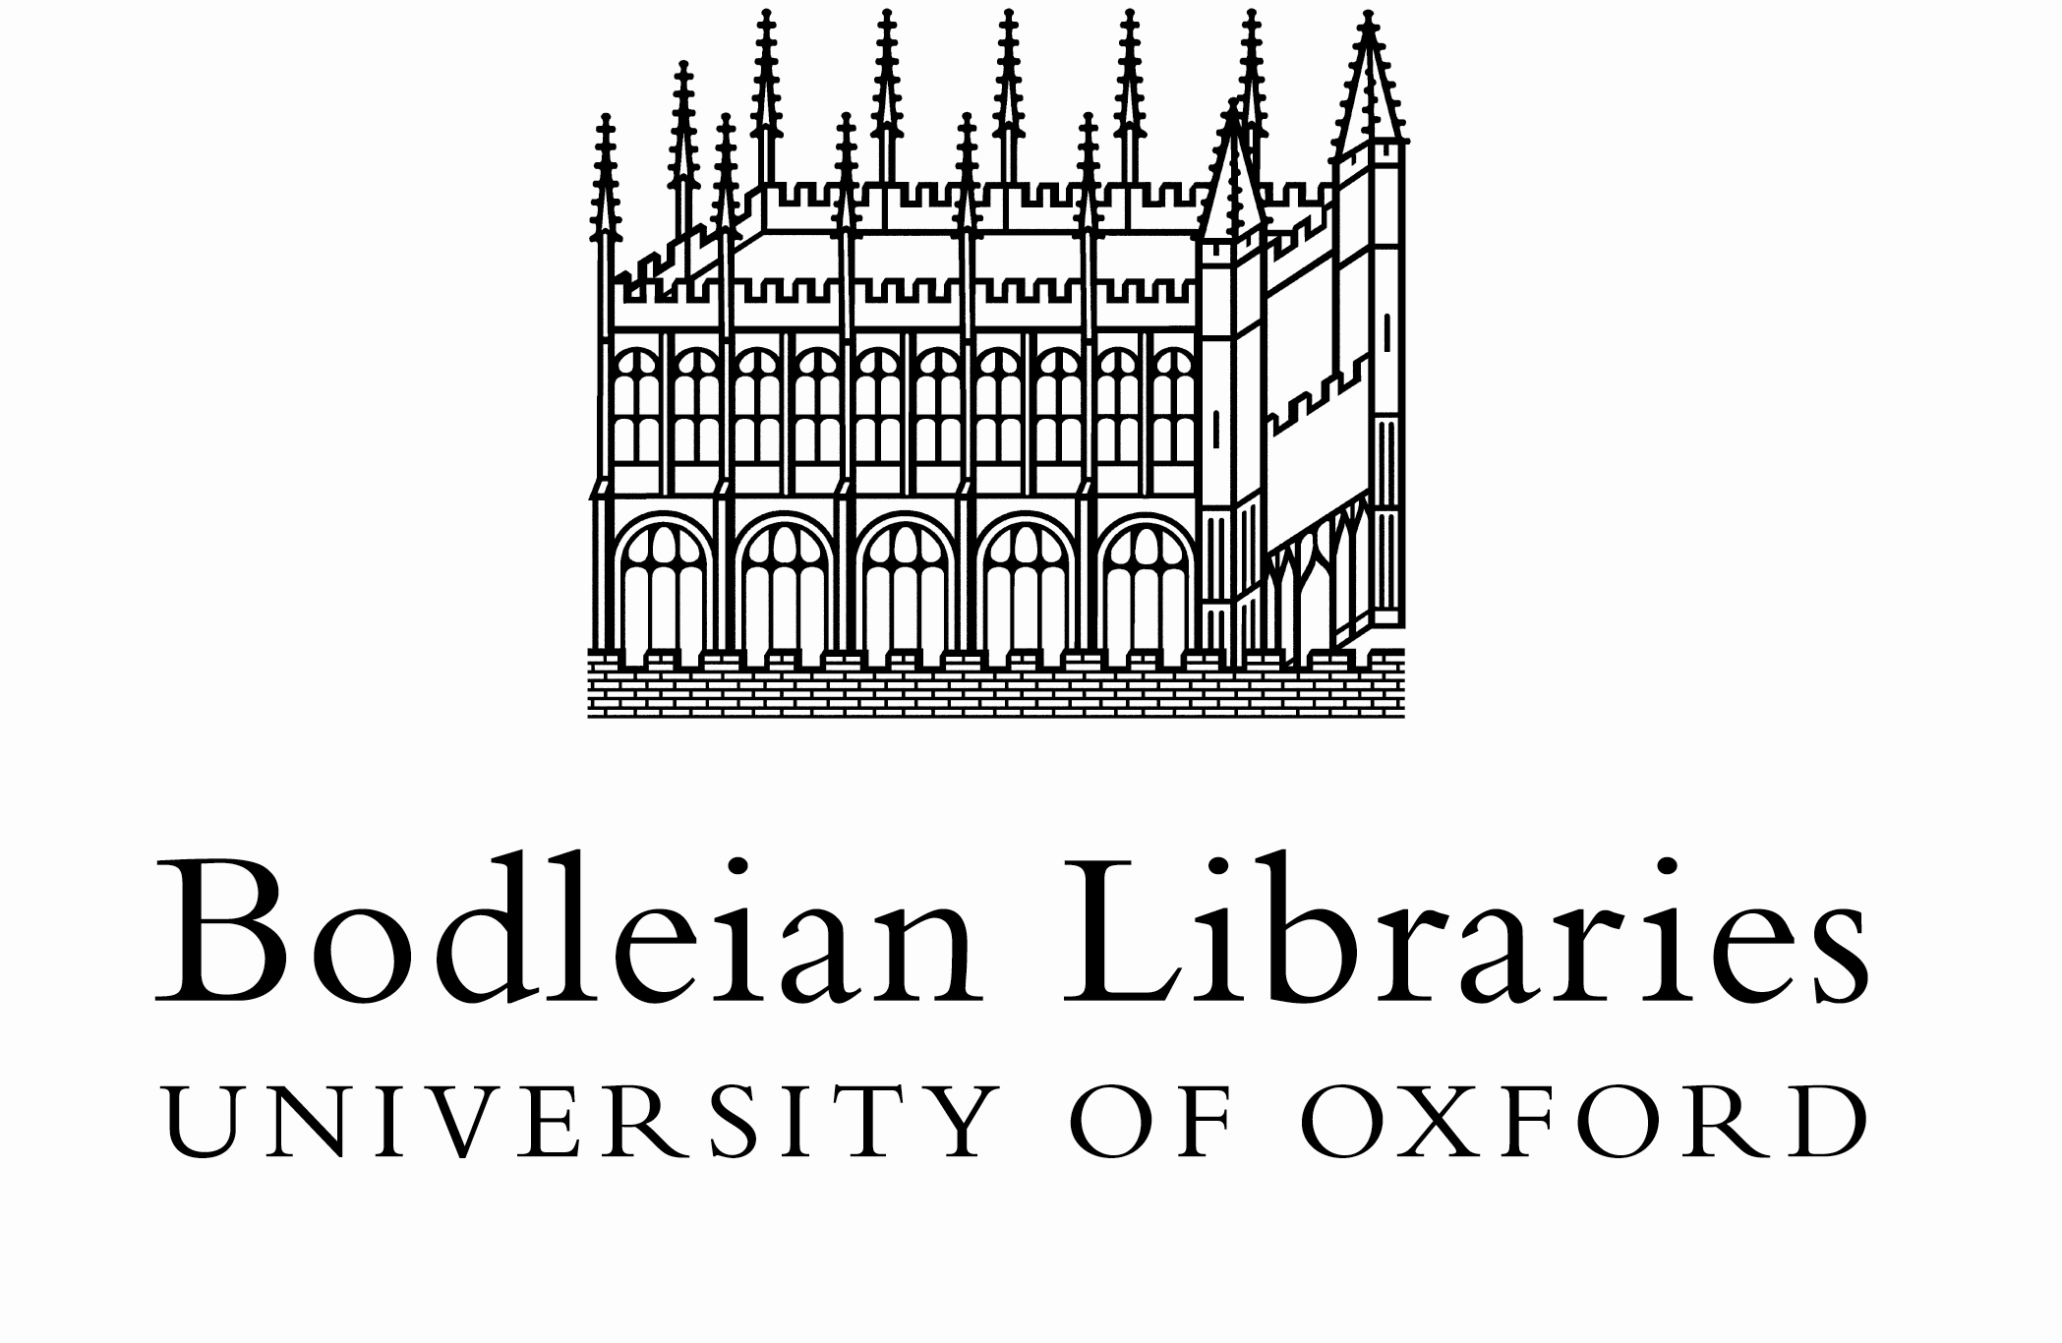
Candidate Name -
This supporting evidence form should explain your relevant experience which may have been gained in employment, education, or you may have taken time away from these activities in order to raise a family, care for a dependant, or travel for example. Your application will be judged solely on the basis of how you demonstrate that that you meet the selection criteria outlined below and we are happy to consider evidence of transferable skills or experience which you may have gained outside the context of paid employment or education.
Essential Criteria | Supporting evidence | For Panel use only  FM/PM/ NM/NE
Why you are interested in this job
Educated to GCSE grades A-C or equivalent skills and experience

Ability to communicate effectively, confidently and courteously with readers, colleagues and the public

Awareness of the importance of good customer care and a commitment to providing excellent quality service

Good general IT literacy including use of email, internet and general applications such as Microsoft Office

Ability to work effectively as part of a team

Ability to undertake routine tasks with care and accuracy

Ability to prioritise and work under pressure

Reliable, punctual
Discreet when dealing with material of a confidential or sensitive nature.

Previous experience of working in a library environment or customer facing environment

Desirable Criteria
Ability to supervise others

Previous experience of using an automated library management system

Familiarity with a range of key online resources e.g. e-journals and databases.

An informed interest in any of the subjects covered in the Radcliffe Camera (currently History and English)

For Panel use only:

Scoring guide to indicate to what degree each applicant meets the selection criteria:

FM (Fully Met) | PM (Partially Met) | NM (Not Met) | NE (No Evidence)

Shortlisting decision

Shortlist / Hold / Reject / Unsubmit?

