Job title | Mechanical Workshop Technician
Division | Mathematical, Physical and Life Sciences Division
Department | Engineering Science
Location | Southwell Laboratory, Osney Mead
Grade and salary | Grade 5: £25,941 - £30,942 per annum
Hours | Full time (36.5 hours per week)
Contract type | Permanent
Reporting to | Principal Technician of Workshop reporting into Professor Ireland
Vacancy reference | 145909
Additional information

The role

You will manufacture, modify and repair research and teaching equipment under the instruction of the Principal Technician. He/she will also provide technical assistance to the research staff, including assisting with experimental programmes of work. Whilst formally line managed by the Donald Schultz Chair in Turbomachinery, Professor Ireland, you will be supervised on a day to day basis by the Principal Technician. You will be a self-motivated individual who excels at working in a team.

The experimental research being conducted by the group is continually evolving and the technician appointed to this post must be willing to learn new skills to provide continued technical support to these activities. Where appropriate, suitable training will be provided and it will not be necessary for a successful applicant to have previous experience of supporting experimental work, provided he/she is willing to develop skills in this area.

Responsibilities
- Working from drawings and CAD files provided by members of the research group, to undertake the manufacture of equipment for use in research and teaching projects.
- To carry out manufacturing tasks which may include milling, turning, manual and CNC.
- To provide technical support to staff and students on the design of equipment, offering ideas and solutions where possible
- To identify and rectify any problems with experimental equipment and/or rigs.
- To install and configure hardware for our wind-tunnels.
- To engage in a process of continuous learning and development, acquiring new skills
- To keep work areas tidy and in good order at all times
- To work at all times with due care and diligence according to the requirements of health and safety, quality and other standards and directions relevant to the assigned task. To instruct on the safe use of equipment and to complete risk assessments as required and adhere to these throughout working practice.
- To work closely with other technical staff and share specialist knowledge when relevant.
- To support the research group’s ISO9001 quality management system by following OTFL106 (and other relevant) quality processes
- To record working time on timesheets and complete any other necessary administrative duties for the effective running of the workshop e.g. maintain records of equipment.
- To participate in the Department’s PDR process and undertake training as necessary.
- Any other tasks that are commensurate with the grading of the post.

Pre-employment screening
All offers of employment are made subject to standard pre-employment screening, as applicable to the post.
If you are offered the post, you will be asked to provide proof of your right-to-work, your identity, and we will contact the referees you have nominated. You will also be asked to complete a health declaration (so that you can tell us about any health conditions or disabilities so that we can discuss appropriate adjustments with you), and a declaration of any unspent criminal convictions.
We advise all applicants to read the candidate notes on the University’s pre-employment screening procedures, found at: www.ox.ac.uk/about/jobs/preemploymentscreening/.

Hazard-specific / Safety-critical duties
This job includes hazards or safety-critical activities. If you are offered the post, you will be asked to complete a health questionnaire which will be assessed by our Occupational Health Service (OHS), and the offer of employment will be subject a successful outcome of this assessment.
The hazards or safety-critical duties involved are as follows:

- Regular manual handling

Selection criteria

Essential selection criteria
- A formal qualification, such as an HNC, BTEC, City and Guilds award or equivalent in an appropriate subject (e.g. mechanical engineering apprenticeship)

- Experience of using standard mechanical workshop equipment (e.g. lathes, milling machines) in an engineering environment.

- Good working knowledge of the theory and application of safety regulations covering workshops and laboratories.

- The communication and interpersonal skills necessary to work effectively and collaboratively as part of a team and with staff and students at all levels of seniority.

- Ability to work collaboratively as part of a team towards a shared objective

- Ability to follow instructions and work to deadlines, recognising when assistance is needed and asking pertinent questions

- Good time management skills with the ability to prioritise tasks, keeping the relevant people informed of progress.

- Ability to work accurately with close attention to detail.

- Good IT skills, e.g. for email or internet searches, CNC work, and the aptitude to learn the use of computer-aided design

Desirable selection criteria
- The desire to increase work skills
- Experience of working in a research or education environment.
- Experience of CNC machining

About the University of Oxford
Welcome to the University of Oxford. We aim to lead the world in research and education for the benefit of society both in the UK and globally. Oxford’s researchers engage with academic, commercial and cultural partners across the world to stimulate high-quality research and enable innovation through a broad range of social, policy and economic impacts.
We believe our strengths lie both in empowering individuals and teams to address fundamental questions of global significance, while providing all our staff with a welcoming and inclusive workplace that enables everyone to develop and do their best work. Recognising that diversity is our strength, vital for innovation and creativity, we aspire to build a truly diverse community which values and respects every individual’s unique contribution.
While we have long traditions of scholarship, we are also forward-looking, creative and cutting-edge. Oxford is one of Europe's most entrepreneurial universities. Income from external research contracts in 2016/17 exceeded £564m and we rank first in the UK for university spin-outs, with more than 130 companies created to date. We are also recognised as leaders in support for social enterprise.
Join us and you will find a unique, democratic and international community, a great range of staff benefits and access to a vibrant array of cultural activities in the beautiful city of Oxford.
For more information, please visit www.ox.ac.uk/about/organisation.

Engineering Science Department

Engineering teaching and research takes place at Oxford in a unified Department of Engineering Science whose academic staff are committed to a common engineering foundation as well as to advanced work in their own specialities, which include most branches of the subject. We have especially strong links with computing, materials science and medicine. The Department employs about 90 academic staff (this number includes 13 statutory Professors appointed in the main branches of the discipline, and 25 other professors in the Department); in addition there are 9 Visiting Professors. There is an experienced team of teaching support staff, clerical staff and technicians. The Department has well-equipped laboratories and workshops, which together with offices, lecture theatres, library and other facilities have a net floor area of about 22,000 square metres. The Department is ranked first in the world in the latest Times Higher Education World University Rankings.
Teaching
We aim to admit 160-170 undergraduates per year, all of whom take a 4-year Engineering Science course leading to the MEng degree. The course is accredited at MEng level by the major engineering institutions. The syllabus has a common core extending through the first two years. Specialist options are introduced in the third year, and the fourth year includes further specialist material and a major project.
Research
The Department was ranked the top engineering department in the UK, as measured by overall GPA, in the Research Excellence Framework 2014 exercise. We have approximately 350 research students and about 130 Research Fellows and Postdoctoral researchers. Funding for research grants and contracts, from a variety of sources, generates an annual turnover of approximately £34m in addition to general turnover of about £24m. The research activities of the department fall into seven broad headings, though there is much overlapping in practice: Thermofluids; Materials and Mechanics; Civil and Offshore; Information, Control and Vision; Electrical and Optoelectronic; Chemical and Process; Biomedical Engineering.

For more information please visit: http://www.eng.ox.ac.uk/

The Department of Engineering Science holds a bronze Athena Swan award to recognise advancement of gender equality: representation, progression and success for all.

Osney Thermo-fluids laboratory

Part of the Department of Engineering Science, the Osney Thermo-Fluids Laboratory is located in a new facility to the west of the city called the Southwell Building.

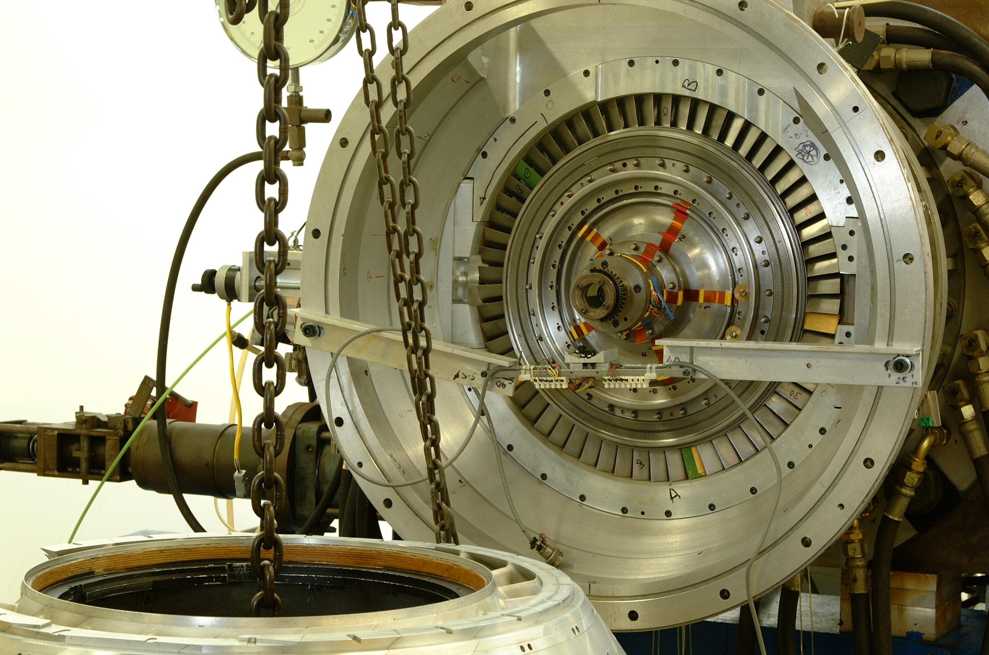

The new laboratory was opened by the Vice Chancellor in 2010 as part of the University's strategic investment in the nation's science base. The lab houses some of the most sophisticated turbine and high speed flow facilities in the UK, and the research group includes internationally recognised experts in CFD, flow and heat transfer experiments and instrumentation.

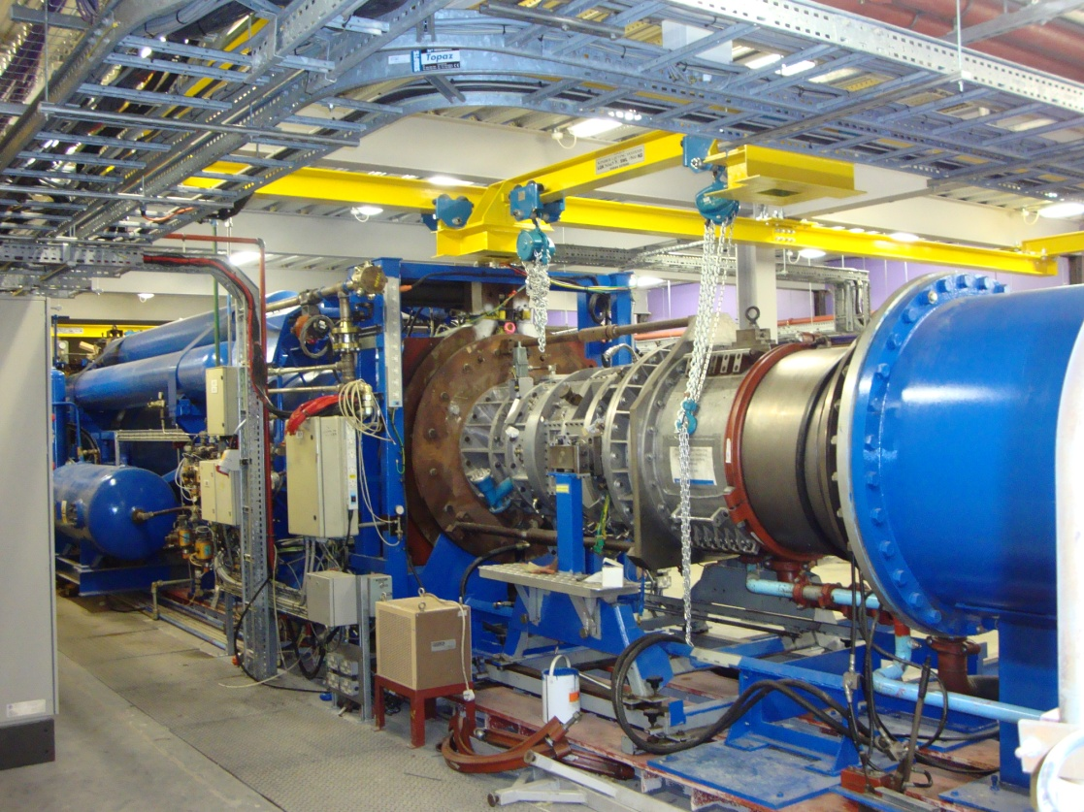

For more information please visit: http://www.eng.ox.ac.uk/thermofluids

The Mathematical, Physical, and Life Sciences Division

The Mathematical, Physical, and Life Sciences (MPLS) Division is one of the four academic divisions of the University. In the results of the six-yearly UK-wide assessment of university research, REF2014, the MPLS division received the highest overall grade point average (GPA) and the highest GPA for outputs. We received the highest proportion of 4* outputs, and the highest proportion of 4* activity overall. More than 50 per cent of MPLS activity was assessed as world leading.

The MPLS Division's 10 departments and 3 interdisciplinary units span the full spectrum of the mathematical, computational, physical, engineering and life sciences, and undertake both fundamental research and cutting-edge applied work. Our research addresses major societal and technological challenges and is increasingly focused on key interdisciplinary issues. MPLS is proud to be the home of some of the most creative and innovative scientific thinkers and leaders working in academe. We have a strong tradition of attracting and nurturing the very best early career researchers who regularly secure prestigious fellowships
We have around 6,000 students and play a major role in training the next generation of leading scientists. Oxford's international reputation for excellence in teaching is reflected in its position at the top of the major league tables and subject assessments.
MPLS is dedicated to bringing the wonder and potential of science to the attention of audiences far beyond the world of academia. We have a strong commitment to supporting public engagement in science through initiatives including the Oxford Sparks portal (http://www.oxfordsparks.net/) and a large variety of outreach activities. We also endeavour to bring the potential of our scientific efforts forward for practical and beneficial application to the real world and our desire is to link our best scientific minds with industry and public policy makers.

For more information about the MPLS division, please visit: http://www.mpls.ox.ac.uk/

How to apply
Before submitting an application, you may find it helpful to read the ‘Tips on applying for a job at the University of Oxford’ document, at www.ox.ac.uk/about/jobs/supportandtechnical/.

If you would like to apply, click on the Apply Now button on the ‘Job Details’ page and follow the on-screen instructions to register as a new user or log-in if you have applied previously. You will then be required to complete a number of screens with your application details, relating to your skills and experience. When prompted, please provide details of two referees (one of which must be your current or most recent employer/supervisor) and indicate whether we can contact them at this stage. You will also be required to upload a supporting statement which explains how you meet the selection criteria for the post.

Supporting Statement
The supporting statement should describe your skills and experience relevant to the post. These may have been gained through employment, education/training, voluntary/community work or you may have taken time away from these activities in order to raise a family, care for a dependent, or travel for example. Your application will be judged solely on the basis of how you demonstrate that that you meet the selection criteria outlined above and we are happy to consider evidence of transferable skills or experience which you may have gained outside the context of paid employment or education. We will short list for interview those whose applications best demonstrate that the applicant meets the selection criteria, so it is important that you use your supporting statement to explain clearly, point by point, how you match them. Please note that a copy of a CV will not be accepted as substitute for a supporting statement and that inclusion of the statement is a mandatory step in the online application process.

References
Please give the details of people who can provide a reference for you. If you have previously been employed, your referees should be people who have managed you, and at least one of them should be your formal line manager in your most recent or current job. Otherwise they may be people who have supervised you in a recent college, school, or voluntary experience. It is helpful if you can tell us briefly how each referee knows you (e.g. ‘line manager’, ‘college tutor’). Your referees should not be related to you.

We will assume that we may approach them at any stage unless you tell us otherwise. If you wish us to ask for your permission before approaching a particular referee, or to contact them only under certain circumstances (for example, if you are called to interview) you must state this explicitly alongside the details of the relevant referee(s).

If you currently work, or have previously worked, for the University of Oxford, we will also take up a reference from the head or administrator of the previous employing department. This will be in addition to taking references from the referees you have provided.

Please upload all documents as PDF files with your name and the document type in the filename.

All applications must be received by midday on the closing date stated in the online advertisement.

Information for priority candidates
A priority candidate is a University employee who is seeking redeployment because they have been advised that they are at risk of redundancy, or on grounds of ill-health/disability. Priority candidates are issued with a redeployment letter by their employing department(s).
If you are a priority candidate, please ensure that you attach your redeployment letter to your application (or email it to the contact address on the advert if the application form used for the vacancy does not allow attachments).

Should you experience any difficulties using the online application system, please email recruitment.support@admin.ox.ac.uk. Further help and support is available from www.ox.ac.uk/about_the_university/jobs/support/. To return to the online application at any stage, please go to: www.recruit.ox.ac.uk.
Please note that you will receive an automated email from our e-recruitment system to confirm receipt of your application. Please check your spam/junk mail if you do not receive this email.

Important information for candidates
Data Privacy
Please note that any personal data submitted to the University as part of the job application process will be processed in accordance with the GDPR and related UK data protection legislation. For further information, please see the University’s Privacy Notice for Job Applicants at: www.admin.ox.ac.uk/councilsec/compliance/gdpr/privacynotices/job/. The University’s Policy on Data Protection is available at: www.admin.ox.ac.uk/councilsec/compliance/gdpr/universitypolicyondataprotection/.

The University’s policy on retirement
The University operates an Employer Justified Retirement Age (EJRA) for all academic posts and some academic-related posts. The University has adopted an EJRA of 30 September before the 69th birthday for all academic and academic-related staff in posts at grade 8 and above. The justification for this is explained at: www.admin.ox.ac.uk/personnel/end/retirement/acrelretire8+/.
For existing employees, any employment beyond the retirement age is subject to approval through the procedures: www.admin.ox.ac.uk/personnel/end/retirement/acrelretire8+/.
There is no normal or fixed age at which staff in posts at grades 1–7 have to retire. Staff at these grades may elect to retire in accordance with the rules of the applicable pension scheme, as may be amended from time to time.

Equality of Opportunity
Entry into employment with the University and progression within employment will be determined only by personal merit and the application of criteria which are related to the duties of each particular post and the relevant salary structure. In all cases, ability to perform the job will be the primary consideration. No applicant or member of staff shall be discriminated against because of age, disability, gender reassignment, marriage or civil partnership, pregnancy or maternity, race, religion or belief, sex, or sexual orientation.
Benefits of working at the University

Employee benefits
University employees enjoy 38 days’ paid holiday, generous pension schemes, travel discounts, and a variety of professional development opportunities. Our range of other employee benefits and discounts also includes free entry to the Botanic Gardens and University colleges, and discounts at University museums. See www.admin.ox.ac.uk/personnel/staffinfo/benefits.

University Club and sports facilities
Membership of the University Club is free for all University staff. The University Club offers social, sporting, and hospitality facilities. Staff can also use the University Sports Centre on Iffley Road at discounted rates, including a fitness centre, powerlifting room, and swimming pool. See www.club.ox.ac.uk and www.sport.ox.ac.uk/oxford-university-sports-facilities.

Information for staff new to Oxford
If you are relocating to Oxfordshire from overseas or elsewhere in the UK, the University's Welcome Service website includes practical information about settling in the area, including advice on relocation, accommodation, and local schools. See www.welcome.ox.ac.uk.
There is also a visa loan scheme to cover the costs of UK visa applications for staff and their dependents. See www.admin.ox.ac.uk/personnel/permits/reimburse&loanscheme/.

Family-friendly benefits
With one of the most generous family leave schemes in the Higher Education sector, and a range of flexible working options, Oxford aims to be a family-friendly employer. We also subscribe to My Family Care, a service that provides practical advice and support for employees who have caring responsibilities. The service offers a free telephone advice line, and the ability to book emergency back-up care for children, adult dependents and elderly relatives. See www.admin.ox.ac.uk/personnel/staffinfo/benefits/family/mfc/.

Childcare
The University has excellent childcare services, including five University nurseries as well as University-supported places at many other private nurseries.
For full details, including how to apply and the costs, see www.admin.ox.ac.uk/childcare/.

Disabled staff
We are committed to supporting members of staff with disabilities or long-term health conditions. For further details, including information about how to make contact, in confidence, with the University’s Staff Disability Advisor, see www.admin.ox.ac.uk/eop/disab/staff.

Staff networks
The University has a number of staff networks including the Oxford Research Staff Society, BME staff network, LGBT+ staff network and a disabled staff network. You can find more information at www.admin.ox.ac.uk/eop/inpractice/networks/.

The University of Oxford Newcomers' Club
The University of Oxford Newcomers' Club is an organisation run by volunteers that aims to assist the partners of new staff settle into Oxford, and provides them with an opportunity to meet people and make connections in the local area. See www.newcomers.ox.ac.uk.

