Job description and selection criteria
Job title | Personal Assistant
Department | Nuffield Department of Surgical Sciences
Location | John Radcliffe Hospital, Level 6
Grade and salary | Grade 5: £25,941 – £30,942 p.a.
Hours | Full-Time (36.5 hours/week)
Contract type | Fixed term until 30th April 2022 in the first instance
Reporting to | Professor Paul Johnson (Professor of Paediatric Surgery and Director of the Oxford Pancreatic Islet Transplant Programme)
Vacancy reference | NDSA787
Additional information | If you have sole caring responsibilities (childcare or medical/elder care) and need to hire professional services to enable you to attend your interview with NDS, we will be happy to reimburse you for these costs in full*.  *Any amount must have prior agreement.

Job description

Professor Johnson is Professor of Paediatric Surgery in the NDS and Director of the Oxford Pancreatic Islet Transplant Programme. In addition to his clinical paediatric surgical activities, he has an active research programme based in the NDS and in the Oxford Centre for Diabetes, Endocrinology and Metabolism on the Churchill site. Professor Johnson runs the nationally-commissioned Islet Transplant Programme in Oxford and is a past-president of the International Pancreas and Islet Transplant Association. He chairs the NHSBT UK Islet Steering Group and is chair of the British Association of Paediatric Surgeons Research Committee. He sits on a number of different Research Boards, including the Royal College of Surgeons Academic and Research Board, the Research Board of the Swedish Diabetes Research and Wellness Foundation, and the Resarch Advisory Board of Defymed. He is the Academic Programme Director for the School of Surgery, and an OUCAGS Academic Training Programme Director. He runs the biennial international Oxford Neonatal Surgery Course, and sits on the Editorial Board of the journals Journal of Paediatric Surgery, European Journal of Paediatric Surgery, and Surgery. He is a Fellow and Clinical Tutor at St Edmund hall, University of Oxford

Overview of the role
Professor Johnson is seeking a personal administrative assistant to support all aspects of his academic programme. The appointee will work in partnership with the core Departmental administrative team in the NDS comprising of the Administrator, Senior Finance Manager, and the Executive Assistant to the Head of Department, to ensure the smooth running of the administrative functions associated with Professor Johnson’s team. This includes finance (monitoring of budgets), and general administration (dealing with staff and visitors to Professor Johnson’s group, preparing grant applications, maintaining and updating the group website, general secretarial and clerical duties, assisting with Editorial work, some aspects of Health and Safety, liaison with the Estate Department of OCDEM), and occasional special projects (such as developing new administrative office systems and websites).

Responsibilities/duties
The main duties of Professor Johnson’s Personal Assistant will include:

- To assist in general administration for Professor Johnson and his research group:
  - Providing confidential support for Professor Johnson.
  - Maintaining an appointment diary and arranging meetings and appointments for Professor Johnson, using initiative to make considered judgements when juggling the demands placed on the schedule
  - Maintaining Professor Johnson’s research websites.
  - Dealing with general enquiries from general public, staff and visitors to Professor Johnson’s group.
  - Organising and maintaining a system of archiving for Professor Johnson and his group.
  - Coordinating registration, accommodation and travel arrangements for Professor Johnson and his staff attending overseas/UK conferences/seminars and ensuring that all necessary accompanying documentation is prepared well in advance to a high standard.
  - Coordinating registration, accommodation and travel arrangements for meetings /seminars hosted by Professor Johnson or his team.
  - Assisting with the preparation, typing and organisation of grant applications for the research team and where possible actively seeking out grant application opportunities.
  - General secretarial duties (including typing letters, memos, reports, manuscripts and figures for papers / book chapters, taking minutes for meetings, making slides using powerpoint, photocopying, filing and answering telephone queries).
  - Database searches when required.

(b) To provide secretarial and administrative support for courses as they occur (eg the Oxford Neonatal Surgery Course):
  - Organising bookings from delegates and payment of registration fees into NDS account.
  - Liaising with speakers, sponsors and venue for course.
  - Providing secretarial and administrative support for all aspects of the preparation and duration of the course.
  - Ensuring all claims and payments for the course are processed.

(c) To assist in financial administration of Professor Johnson’s research group in partnership with the Departmental administrative team:
  - To administer the financial claims for Professor Johnson’s travel.
  - Assist the Administrator with the financial management of Professor Johnson’s group including, where necessary, using the computerised finance system.
  - Monitoring of Professor Johnson’s research grants and other funds available to his group.

(d) To assist with special projects
  - Co-ordinating ad-hoc projects, e.g. website development, laboratory and office maintenance and refurbishment.
  - Developing new administrative office systems.

(e) To liaise and work closely with the pool of departmental PA’s

This job description is not intended to be exhaustive. The postholder will, therefore, be expected to adopt a flexible attitude to the duties that may vary within the general profile of the job.

Pre-employment screening
All offers of employment are made subject to standard pre-employment screening, as applicable to the post.

If you are offered the post, you will be asked to provide proof of your right-to-work, your identity, and we will contact the referees you have nominated. You will also be asked to complete a health declaration (so that you can tell us about any health conditions or disabilities so that we can discuss appropriate adjustments with you), and a declaration of any unspent criminal convictions.

We advise all applicants to read the candidate notes on the University’s pre-employment screening procedures, found at: www.ox.ac.uk/about/jobs/preemploymentscreening/.

Selection criteria

Essential

The successful candidate for the post of Personal Assistant will be required to demonstrate:

- Experience of diary management, including making complex travel arrangements;
- The ability to use initiative and to work flexibly;
- Excellent attention to detail and ability to work methodically;
- The ability to organise and prioritise work in order to meet deadlines, including coping with unpredictable volumes of work and busy periods without the need for close supervision;
- Excellent computer skills, including word processing, databases, email and a variety of other office applications;
- The ability to work effectively as part of a small team, and to assist in different areas as required;
- A high standard of numeracy; the ability to manage finances
- Experience of working on confidential matters; tact and discretion
- Ability to adapt to new working methods and willingness to undertake relevant training;
- The ability to communicate effectively and to a high standard in writing as well as orally;
- The ability to build effective working relationships with immediate colleagues and to deal tactfully and effectively with a wide range of contacts, including senior academics, students and other university staff.

Desirable

- Audio-typing experience;
- Previous experience of work in a university or hospital environment;
- Familiarity with Oracle accounting system;
- Experience of maintaining web pages.

Please note that the appointment of the successful candidate will be subject to standard compulsory pre-employment screening, such as right to work checks.

Please click here to read the candidate notes on the University’s pre-employment screening procedures.

About the University of Oxford
Welcome to the University of Oxford. We aim to lead the world in research and education for the benefit of society both in the UK and globally. Oxford’s researchers engage with academic, commercial and cultural partners across the world to stimulate high-quality research and enable innovation through a broad range of social, policy and economic impacts.

We believe our strengths lie both in empowering individuals and teams to address fundamental questions of global significance, while providing all our staff with a welcoming and inclusive workplace that enables everyone to develop and do their best work. Recognising that diversity is our strength, vital for innovation and creativity, we aspire to build a truly diverse community which values and respects every individual’s unique contribution.

While we have long traditions of scholarship, we are also forward-looking, creative and cutting-edge. Oxford is one of Europe's most entrepreneurial universities. Income from external research contracts in 2016/17 exceeded £564m and we rank first in the UK for university spin-outs, with more than 130 companies created to date. We are also recognised as leaders in support for social enterprise.

Join us and you will find a unique, democratic and international community, a great range of staff benefits and access to a vibrant array of cultural activities in the beautiful city of Oxford.
For more information, please visit www.ox.ac.uk/about/organisation

Medical Sciences Division
The Medical Sciences Division is an internationally recognized centre of excellence for biomedical and clinical research and teaching. We are the largest academic division in the University of Oxford.

World-leading programmes, housed in state-of-the-art facilities, cover the full range of scientific endeavour from the molecule to the population. With our NHS partners we also foster the highest possible standards in patient care.

For more information please visit: www.medsci.ox.ac.uk

Nuffield Department of Surgical Sciences
The Nuffield Department of Surgical Sciences is one of the few remaining academic surgical departments in the UK. The Department currently hosts academics from every surgical discipline who undertake both basic and translational research, reflecting our true multidisciplinary dimension and integrating surgical practice with cutting-edge science. The department has outstanding research programmes in oncology, transplantation, immunology and regenerative medicine, neuroscience, otolaryngology, and cardiothoracic and vascular surgery. In recent years the department has taken a new exciting direction to strengthen academic surgical oncology, as a key component of the CRUK Cancer Centre together with Medical and Clinical Oncology, and the new Cancer Centre structure of the Oxford University Hospitals NHS Trust. Another key topic in NDS is Transplantation, with dedicated experimental and translational research including national and international collaboration.

Teaching is also a major component in our activity, encompassing undergraduate, graduate and postgraduate students in all surgical disciplines. The department also co-hosts Masters courses in Integrated Immunology and Surgical Sciences and Practice.

For more information please visit: www.nds.ox.ac.uk


Athena SWAN Charter
The Athena SWAN Awards recognise success in working towards gender equality in the workplace. As a Silver award holder, NDS has established a culture of inclusivity and are using the Athena SWAN process to continue developing practices that champion diversity, to the benefit of everyone in the Department. Our department is committed to:

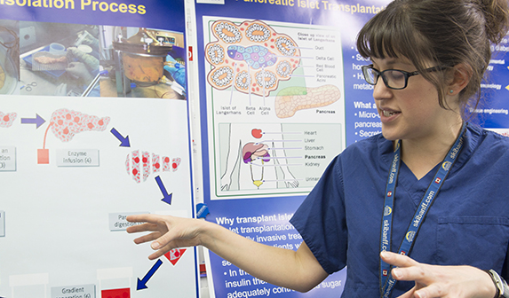
- establishing an open, supportive and family-friendly working culture
- supporting career progression through teaching programmes, performance reviews and mentoring.
- proactive communication of flexible working and parental leave policies

NDS actively promotes family-friendly policies to help foster a family-friendly working environment, including provision of family leave (including shared parental, carers and adoption leave), flexible/part-time working and scheduling meetings within core hours that are compatible with personal/family commitments.

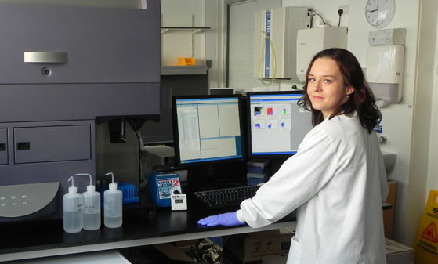
The University’s childcare services support staff with Tax Free Childcare to help staff save tax and national insurance on childcare costs, and we offer information on nursery providers and a nursery fee Salary Sacrifice Scheme. Our partnership with playscheme providers helps to support families during school holidays and signpost staff to parenting, local authority and other organisations that help support families and parents.
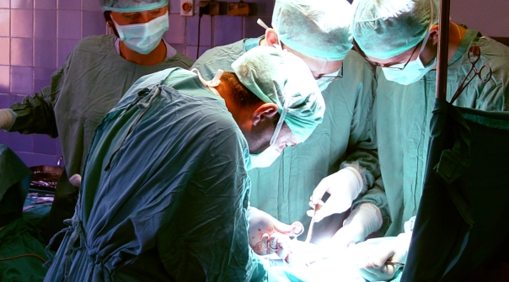
The Department is committed to ensuring that staff undertaking part-time or flexible working receive the same access to benefits and entitlements as full-time staff, including the same opportunities for training and promotion, a pro-rata entitlement to leave including bank holidays and careful consideration of requests to work part-time (particularly for those by staff returning from maternity leave).

For more information please visit:
http://www.admin.ox.ac.uk/personnel/staffinfo/benefits/family/ and
http://www.admin.ox.ac.uk/personnel/during/flexible/

We work to uphold the University’s aim of providing an inclusive environment with equal career opportunities by promoting equality, valuing diversity and ensuring the rights and dignity of all staff are respected. Separate University policies are also in place to ensure race, disability and gender equality.

For more information, please visit:
http://www.admin.ox.ac.uk/eop/missionstatement/integratedequalitypolicy/

How to apply
Before submitting an application, you may find it helpful to read the ‘Tips on applying for a job at the University of Oxford’ document, at www.ox.ac.uk/about/jobs/supportandtechnical/.

If you would like to apply, click on the Apply Now button on the ‘Job Details’ page and follow the on-screen instructions to register as a new user or log-in if you have applied previously. Please provide details of two referees and indicate whether we can contact them now.

You will also be asked to upload a CV and a supporting statement. The supporting statement must explain how you meet each of the selection criteria for the post using examples of your skills and experience. This may include experience gained in employment, education, or during career breaks (such as time out to care for dependants).

Your application will be judged solely on the basis of how you demonstrate that you meet the selection criteria stated in the job description.

Please upload all documents as PDF files with your name and the document type in the filename.

All applications must be received by midday on the closing date stated in the online advertisement.

Information for priority candidates
A priority candidate is a University employee who is seeking redeployment because they have been advised that they are at risk of redundancy, or on grounds of ill-health/disability. Priority candidates are issued with a redeployment letter by their employing department(s).
If you are a priority candidate, please ensure that you attach your redeployment letter to your application (or email it to the contact address on the advert if the application form used for the vacancy does not allow attachments).

Should you experience any difficulties using the online application system, please email recruitment.support@admin.ox.ac.uk. Further help and support is available from www.ox.ac.uk/about_the_university/jobs/support/. To return to the online application at any stage, please go to: www.recruit.ox.ac.uk.

Please note that you will receive an automated email from our e-recruitment system to confirm receipt of your application. Please check your spam/junk mail if you do not receive this email.

Important information for candidates

Data Privacy
Please note that any personal data submitted to the University as part of the job application process will be processed in accordance with the GDPR and related UK data protection legislation. For further information, please see the University’s Privacy Notice for Job Applicants at: www.admin.ox.ac.uk/councilsec/compliance/gdpr/privacynotices/job/. The University’s Policy on Data Protection is available at: www.admin.ox.ac.uk/councilsec/compliance/gdpr/universitypolicyondataprotection/.

The University’s policy on retirement
The University operates an Employer Justified Retirement Age (EJRA) for all academic posts and some academic-related posts. The University has adopted an EJRA of 30 September before the 69th birthday for all academic and academic-related staff in posts at grade 8 and above. The justification for this is explained at: www.admin.ox.ac.uk/personnel/end/retirement/acrelretire8+/.

For existing employees, any employment beyond the retirement age is subject to approval through the procedures: www.admin.ox.ac.uk/personnel/end/retirement/acrelretire8+/.

There is no normal or fixed age at which staff in posts at grades 1–7 have to retire. Staff at these grades may elect to retire in accordance with the rules of the applicable pension scheme, as may be amended from time to time.

Equality of Opportunity
Entry into employment with the University and progression within employment will be determined only by personal merit and the application of criteria which are related to the duties of each particular post and the relevant salary structure. In all cases, ability to perform the job will be the primary consideration. No applicant or member of staff shall be discriminated against because of age, disability, gender reassignment, marriage or civil partnership, pregnancy or maternity, race, religion or belief, sex, or sexual orientation.

Benefits of working at the University

Employee benefits
University employees enjoy 38 days’ paid holiday, generous pension schemes, travel discounts, and a variety of professional development opportunities. Our range of other employee benefits and discounts also includes free entry to the Botanic Gardens and University colleges, and discounts at University museums. See www.admin.ox.ac.uk/personnel/staffinfo/benefits.

University Club and sports facilities
Membership of the University Club is free for all University staff. The University Club offers social, sporting, and hospitality facilities. Staff can also use the University Sports Centre on Iffley Road at discounted rates, including a fitness centre, powerlifting room, and swimming pool. See www.club.ox.ac.uk and www.sport.ox.ac.uk/oxford-university-sports-facilities.

Information for staff new to Oxford
If you are relocating to Oxfordshire from overseas or elsewhere in the UK, the University's Welcome Service website includes practical information about settling in the area, including advice on relocation, accommodation, and local schools. See www.welcome.ox.ac.uk.
There is also a visa loan scheme to cover the costs of UK visa applications for staff and their dependents. See www.admin.ox.ac.uk/personnel/permits/reimburse&loanscheme/.

Family-friendly benefits
With one of the most generous family leave schemes in the Higher Education sector, and a range of flexible working options, Oxford aims to be a family-friendly employer. We also subscribe to My Family Care, a service that provides practical advice and support for employees who have caring responsibilities. The service offers a free telephone advice line, and the ability to book emergency back-up care for children, adult dependents and elderly relatives. See www.admin.ox.ac.uk/personnel/staffinfo/benefits/family/mfc/.

Childcare
The University has excellent childcare services, including five University nurseries as well as University-supported places at many other private nurseries.
For full details, including how to apply and the costs, see www.admin.ox.ac.uk/childcare/.

Disabled staff
We are committed to supporting members of staff with disabilities or long-term health conditions. For further details, including information about how to make contact, in confidence, with the University’s Staff Disability Advisor, see www.admin.ox.ac.uk/eop/disab/staff.

Staff networks
The University has a number of staff networks including the Oxford Research Staff Society, BME staff network, LGBT+ staff network and a disabled staff network. You can find more information at www.admin.ox.ac.uk/eop/inpractice/networks/.

The University of Oxford Newcomers' Club
The University of Oxford Newcomers' Club is an organisation run by volunteers that aims to assist the partners of new staff settle into Oxford, and provides them with an opportunity to meet people and make connections in the local area. See www.newcomers.ox.ac.uk.

