Job title | Human Factors Research Fellow
Division | Medical Sciences
Department | Nuffield Department of Surgical Sciences
Location | John Radcliffe Hospital, Oxford
Grade and salary | Grade 7: £36,024 - £44,263 per annum
Hours | Full time (part-time working as part of a job-share arrangement may be considered)
Contract type | Fixed-term until 31 May 2025
Reporting to | Professor Peter McCulloch
Vacancy reference | NDSA924
Additional information | If you have sole caring responsibilities (childcare or medical/elder care) and need to hire professional services to enable you to attend your interview with NDS, we will be happy to reimburse you for these costs in full*.  *Any amount must have prior agreement.

Research topic | Rescue for Emergency Surgery Patients Observed to uNdergo acute Deterioration (RESPOND)
Principal Investigator / supervisor | Professor Peter McCulloch
Project team | NIHR/RESPOND Patient Safety Academy
Funding partner | The funds supporting this research project are provided by NIHR

The role

Reporting to the RESPOND Programme Chief Investigator, Professor Peter McCulloch. The post holder is a member of the Quality, Reliability, Safety and Teamwork Unit (QRSTU) with responsibility for carrying out research for the RESPOND Programme. The RESPOND programme is a five-year research programme which uses Human Factors principles to investigate and improve processes involved in the response to patients deteriorating after emergency surgery. The post holder will be a key player in the delivery of Work Package 4, the cluster-randomised trial of the intervention. They will introduce the interventions to clinical staff and guide their implementation using a weekly quality improvement cycle in co-designing modifications with clinical leaders. They will deliver human factors training to staff at participating hospitals, ensure staff engagement and monitor participation. They will also participate in data analysis and writing of reports, scientific papers and presentations. The post holder will also provide guidance to junior members of the research group including research assistants, PhD students, and project volunteers.

Responsibilities

- Utilise existing human factors methodologies and develop new research methodologies and materials to increase understanding of healthcare systems.
- Deliver Human Factors training to a wide range of staff at participating sites on the RESPOND Programme. This will incorporate a teamwork strengthening programme for staff and a Change Leadership programme for selected clinical Leads. Travel to sites in-person will be required.
- Lead on delivery and improvement of a Human Factors-based intervention bundle designed to improve hospital responses to the deteriorating post-operative patient. This will include co-design and iterative improvement of change programmes using a Quality Improvement approach
- Manage own portfolio of academic research and administrative activities. This involves small scale project management within the work packages, to co-ordinate different aspects of work to meet deadlines
- Act as a source of information and advice to other members of the group on Human Factors methodologies and procedures
- Mentor Clinical Research Fellows and junior scientists using your professional knowledge and expertise, where appropriate
- Analyse qualitative and quantitative data from a variety of sources, reviewing and refining relevant theories as appropriate
- Collaborate in the preparation of research publications, conference presentations, grant applications and book chapters
- Present papers at conferences or public meetings and represent the QRSTU and the RESPOND Programme at external meetings/seminars,
- Carry out collaborative projects with colleagues in partner institutions, and research groups as part of the RESPOND Programme and/or the QRSTU
- Beyond work in the RESPOND programme, develop ideas for generating research income, and present detailed research proposals and reports to senior researchers and public meetings

Pre-employment screening

Standard checks
If you are offered the post, the offer will be subject to standard pre-employment checks. You will be asked to provide: proof of your right-to-work in the UK; proof of your identity; and (if we haven’t done so already) we will contact the referees you have nominated. You will also be asked to complete a health declaration so that you can tell us about any health conditions or disabilities for which you may need us to make appropriate adjustments.

Please read the candidate notes on the University’s pre-employment screening procedures at: https://www.jobs.ox.ac.uk/pre-employment-checks

Hazard-specific / Safety-critical duties
This job includes hazards or safety-critical activities. If you are offered the post, you will be asked to complete a health questionnaire which will be assessed by our Occupational Health Service (OHS), and the offer of employment will be subject a successful outcome of this assessment.

The hazards or safety-critical duties involved are as follows:

      - Lone Working
- Work in clinical areas with direct contact with patients

Selection criteria

Essential selection criteria

- PhD in a relevant subject
- Previous research experience in human factors methodologies
- Experience of delivering Human Factors training to healthcare professionals
- Excellent oral and written communication skills, combined with good diplomatic and interpersonal skills
- Excellent Computer literacy, including all basic Microsoft Office programmes and data analysis software programmes including SPSS
- Ability to multi-task and adapt to changing workloads as required
- Excellent decision-making and problem-solving skills
- Able to lead and support junior members of the research group

Desirable selection criteria
- Familiarity with FRAM and FMEA
- Experience of practical systems improvement intervention work
- Experience of working in a healthcare setting
- Experience of working within an academic research group

About the University of Oxford
Welcome to the University of Oxford. We aim to lead the world in research and education for the benefit of society both in the UK and globally. Oxford’s researchers engage with academic, commercial and cultural partners across the world to stimulate high-quality research and enable innovation through a broad range of social, policy and economic impacts.

We believe our strengths lie both in empowering individuals and teams to address fundamental questions of global significance, while providing all our staff with a welcoming and inclusive workplace that enables everyone to develop and do their best work. Recognising that diversity is our strength, vital for innovation and creativity, we aspire to build a truly diverse community which values and respects every individual’s unique contribution.

While we have long traditions of scholarship, we are also forward-looking, creative and cutting-edge. Oxford is one of Europe's most entrepreneurial universities and we rank first in the UK for university spin-outs, and in recent years we have spun out 15-20 new companies every year. We are also recognised as leaders in support for social enterprise.

Join us and you will find a unique, democratic and international community, a great range of staff benefits and access to a vibrant array of cultural activities in the beautiful city of Oxford.

For more information, please visit www.ox.ac.uk/about/organisation.

Medical Sciences Division
The Medical Sciences Division is an internationally recognized centre of excellence for biomedical and clinical research and teaching. We are the largest academic division in the University of Oxford.

World-leading programmes, housed in state-of-the-art facilities, cover the full range of scientific endeavour from the molecule to the population. With our NHS partners we also foster the highest possible standards in patient care.

For more information please visit: www.medsci.ox.ac.uk

Nuffield Department of Surgical Sciences
The Nuffield Department of Surgical Sciences is one of the few remaining academic surgical departments in the UK. The Department currently hosts academics from every surgical discipline who undertake both basic and translational research, reflecting our true multidisciplinary dimension and integrating surgical practice with cutting-edge science. The department has outstanding research programmes in oncology, transplantation, immunology and regenerative medicine, clinical research methodology in surgery (IDEAL), human factors in surgery, neuroscience, otolaryngology, and cardiothoracic and vascular surgery. In recent years the department has taken a new exciting direction to strengthen academic surgical oncology, as a key component of the CRUK Cancer Centre together with Medical and Clinical Oncology, and the new Cancer Centre structure of the Oxford University Hospitals NHS Trust. Another key topic in NDS is Transplantation, with dedicated experimental and translational research including national and international collaboration.

Teaching is also a major component in our activity, encompassing undergraduate, graduate and postgraduate students in all surgical disciplines. The department also co-hosts Masters courses in Integrated Immunology and Surgical Sciences and Practice.

For more information please visit: www.nds.ox.ac.uk

Athena SWAN Charter

The Athena SWAN Awards recognise success in working towards gender equality in the workplace. As a Silver award holder, NDS has established a culture of inclusivity and are using the Athena SWAN process to continue developing practices that champion diversity, to the benefit of everyone in the Department. Our department is committed to:

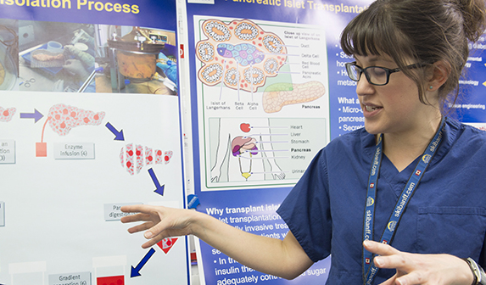
- establishing an open, supportive and family-friendly working culture
- supporting career progression through teaching programmes, performance reviews and mentoring.
- proactive communication of flexible working and parental leave policies

NDS actively promotes family-friendly policies to help foster a family-friendly working environment, including provision of family leave (including shared parental, carers and adoption leave), flexible/part-time working and scheduling meetings within core hours that are compatible with personal/family commitments.

The University’s childcare services support staff with Tax Free Childcare to help staff save tax and national insurance on childcare costs, and we offer information on nursery providers and a nursery fee Salary Sacrifice Scheme. Our partnership with playscheme providers helps to support families during school holidays and signpost staff to parenting, local authority and other organisations that help support families and parents.

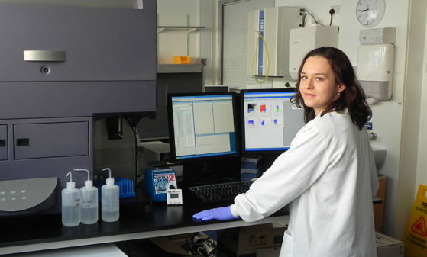
The Department is committed to ensuring that staff undertaking part-time or flexible working receive the same access to benefits and entitlements as full-time staff, including the same opportunities for training and promotion, a pro-rata entitlement to leave including bank holidays and careful consideration of requests to work part-time (particularly for those by staff returning from maternity leave).

For more information please visit:
http://www.admin.ox.ac.uk/personnel/staffinfo/benefits/family/ and
http://www.admin.ox.ac.uk/personnel/during/flexible/
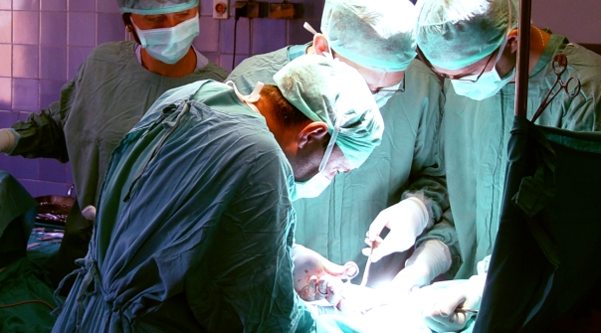
We work to uphold the University’s aim of providing an inclusive environment with equal career opportunities by promoting equality, valuing diversity and ensuring the rights and dignity of all staff are respected. Separate University policies are also in place to ensure race, disability and gender equality.

For more information, please visit:
http://www.admin.ox.ac.uk/eop/missionstatement/integratedequalitypolicy/

How to apply
Applications are made through our e-recruitment system and you will find all the information you need about how to apply on our Jobs website https://www.jobs.ox.ac.uk/how-to-apply.

Your application will be judged solely on the basis of how you demonstrate that you meet the selection criteria stated in the job description.

As part of your application you will be asked to provide details of two referees and indicate whether we can contact them now.

You will be asked to upload a CV and a supporting statement. The supporting statement must explain how you meet each of the selection criteria for the post using examples of your skills and experience. This may include experience gained in employment, education, or during career breaks (such as time out to care for dependants)

Please upload all documents as PDF files with your name and the document type in the filename.

All applications must be received by midday UK time on the closing date stated in the online advertisement.

Information for priority candidates
A priority candidate is a University employee who is seeking redeployment because they have been advised that they are at risk of redundancy, or on grounds of ill-health/disability. Priority candidates are issued with a redeployment letter by their employing department(s).
If you are a priority candidate, please ensure that you attach your redeployment letter to your application (or email it to the contact address on the advert if the application form used for the vacancy does not allow attachments).

If you need help

Help and support is available from: https://hrsystems.admin.ox.ac.uk/recruitment-support

If you require any further assistance please email recruitment.support@admin.ox.ac.uk.

To return to the online application at any stage, please go to: www.recruit.ox.ac.uk.

Please note that you will receive an automated email from our e-recruitment system to confirm receipt of your application. Please check your spam/junk mail if you do not receive this email.

Important information for candidates

Data Privacy
Please note that any personal data submitted to the University as part of the job application process will be processed in accordance with the GDPR and related UK data protection legislation. For further information, please see the University’s Privacy Notice for Job Applicants at: https://compliance.admin.ox.ac.uk/job-applicant-privacy-policy. The University’s Policy on Data Protection is available at: https://compliance.admin.ox.ac.uk/data-protection-policy.

The University’s policy on retirement
The University operates an Employer Justified Retirement Age (EJRA) for all academic posts and some academic-related posts. The University has adopted an EJRA of 30 September before the 69th birthday for all academic and academic-related staff in posts at grade 8 and above. The justification for this is explained at: https://hr.admin.ox.ac.uk/the-ejra

For existing employees, any employment beyond the retirement age is subject to approval through the procedures: https://hr.admin.ox.ac.uk/the-ejra

There is no normal or fixed age at which staff in posts at grades 1–7 have to retire. Staff at these grades may elect to retire in accordance with the rules of the applicable pension scheme, as may be amended from time to time.

Equality of opportunity
Entry into employment with the University and progression within employment will be determined only by personal merit and the application of criteria which are related to the duties of each particular post and the relevant salary structure. In all cases, ability to perform the job will be the primary consideration. No applicant or member of staff shall be discriminated against because of age, disability, gender reassignment, marriage or civil partnership, pregnancy or maternity, race, religion or belief, sex, or sexual orientation.

Benefits of working at the University

Employee benefits
University employees enjoy 38 days’ paid holiday, generous pension schemes, travel discounts, and a variety of professional development opportunities. Our range of other employee benefits and discounts also includes free entry to the Botanic Gardens and University colleges, and discounts at University museums. See https://hr.admin.ox.ac.uk/staff-benefits

University Club and sports facilities
Membership of the University Club is free for all University staff. The University Club offers social, sporting, and hospitality facilities. Staff can also use the University Sports Centre on Iffley Road at discounted rates, including a fitness centre, powerlifting room, and swimming pool. See www.club.ox.ac.uk and https://www.sport.ox.ac.uk/.

Information for staff new to Oxford
If you are relocating to Oxfordshire from overseas or elsewhere in the UK, the University's Welcome Service website includes practical information about settling in the area, including advice on relocation, accommodation, and local schools. See https://welcome.ox.ac.uk/

There is also a visa loan scheme to cover the costs of UK visa applications for staff and their dependents. See https://staffimmigration.admin.ox.ac.uk/visa-loan-scheme

Family-friendly benefits
With one of the most generous family leave schemes in the Higher Education sector, and a range of flexible working options, Oxford aims to be a family-friendly employer. We also subscribe to the Work+Family Space, a service that provides practical advice and support for employees who have caring responsibilities. The service offers a free telephone advice line, and the ability to book emergency back-up care for children, adult dependents and elderly relatives. See https://hr.admin.ox.ac.uk/my-family-care Child
care
The University has excellent childcare services, including five University nurseries as well as University-supported places at many other private nurseries.

For full details, including how to apply and the costs, see https://childcare.admin.ox.ac.uk/

Disabled staff
We are committed to supporting members of staff with disabilities or long-term health conditions. For further details, including information about how to make contact, in confidence, with the University’s Staff Disability Advisor, see https://edu.admin.ox.ac.uk/disability-support

Staff networks
The University has a number of staff networks including the Oxford Research Staff Society, BME staff network, LGBT+ staff network and a disabled staff network. You can find more information at https://edu.admin.ox.ac.uk/networks

The University of Oxford Newcomers' Club
The University of Oxford Newcomers' Club is an organisation run by volunteers that aims to assist the partners of new staff settle into Oxford, and provides them with an opportunity to meet people and make connections in the local area. See www.newcomers.ox.ac.uk.

