Job description and selection criteria
Job title | Research Technician in Human Islet Isolation
Division | Medical Sciences
Department | Nuffield Department of Surgical Sciences
Location | OCDEM, Churchill Hospital (this post requires full time onsite working)
Grade and salary | Grade 5: £30,259 - £35,466 per annum including the Oxford University Weighting of £1,500 per annum
Hours | Full time (36.5 hours per week + participation in an on-call rota)
Contract type | Fixed-term until 31st August 2025
Reporting to | Dr Rebecca Spiers (Islet Facility Manager) and Professor Paul Johnson (Islet Facility Director)
Vacancy reference | NDSA946
Additional information | If you have sole caring responsibilities (childcare or medical/elder care) and need to hire professional services to enable you to attend your interview with NDS, we will be happy to reimburse you for these costs in full*.  *Any amount must have prior agreement.

Research topic | Optimising islet isolation for transplantation
Principal Investigator | Prof Paul RV Johnson
Project team | Johnson Group / Islet Transplant Research Group
Project web site | https://www.nds.ox.ac.uk/research/oxcit
Funding partner | Juvenile Diabetes Research Foundation (JDRF)
Recent publications | High concentrations of Etanercept Reduce Human Islet Function and Integrity. Brandhorst D., Brandhorst H., Acreman S., Abraham A., Johnson PRV. J Inflam Res 2021. DOI: 10.2147/JIR.S294663  Donor age significantly influences the Raman spectroscopic biomolecular fingerprint of human pancreatic extracellular matrix proteins following collagenase-based digestion.  Spiers RM, Marzi J, Brauchle EM, Cross SE, Vaughan RH, Bateman PA, Hughes SJ, Schenke-Layland K, Johnson PRV. Acta Biomater. 2019: S1742-7061(19)30625-7

The role

Overview of the role
The Oxford Human Islet Isolation Facility is one of the few purpose-built GMP islet isolation facilities in Europe and the NDS Islet Transplant Research Group has an international standing. This post within the Group is funded by the Juvenile Diabetes Research Foundation to support a Research Technician in human islet isolation for the isolation, provision and distribution of human islets to research centres throughout the UK. The technician is required to participate in islet isolation procedures primarily for the research programme isolating and supplying islet cells for study in Oxford and elsewhere but also will be expected to participate on the clinical rota in a quid pro quo arrangement with Department of Health funded Technicians in the group who in turn support the research activity. The successful applicant will take responsibility for coordinating the distribution of the islets and maintaining & updating a database recording this process. As well as these duties, there will be an opportunity to carry out research under the supervision of a senior scientist into an aspect of islet isolation, islet pre-conditioning or islet transplantation.

Responsibilities/duties
- Take primary responsibility for improving, maintaining & updating the Islet database to ensure equitable distribution and record disposal of islet preparations in accordance with Human Tissue Authority (HTA) requirements.
- Participate in all aspects of the clinical islet isolation procedure (including the preparation and set up of the lab and decontamination and clean-up procedures).
- Take part in research islet isolations, including isolation of islets from donors with diabetes.
- Participate in the out-of-hours rota (with compensatory remuneration for hours worked).
- Take responsibility for distribution of islets to participating research centres in the UK.
- Monitors equipment, ensures data collection and recording of data as appropriate.
- Ensures adherence to local policy and health and safety guidelines.
- Carry out quality and islet function testing of preparations such as islet viability and insulin release assays in conjunction with other staff.
- Ensures appropriate quantities of sterilised equipment and consumables are available at all times, monitors stock levels and ensures that orders are placed to replenish supplies.
- Monitoring and makes up reagents as required ensuring adequate stocks are maintained at all times.
- Monitoring consumable stocks and equipment operation to ensure the laboratory is able to function efficiently at all times.
- Monitoring the air handling system, laboratory room pressures and temperature-controlled devises daily.
- Participate in quality assurance and other training as appropriate.
- Perform washing up and sample disposal when required.
- Participate in supervised research projects related to the Islet Facility.
- Keeping accurate records of work carried out and on the laboratory computer systems.
- Liaising with senior staff concerning problems that may arise.
- Actively participates in laboratory meetings.
- Report to the Facility Manager and Facility Director.
- From time to time the post holder may be required to perform other duties relating to this position appropriate to the grade that are not specified in this document.

Selection criteria

Essential
- A Level (or equivalent) in Maths or Computing Science and Biological Science or Chemistry
- Practical experience with setting up or management/ maintenance of a database
- Practical laboratory experience
- Demonstrated ability to work accurately
- Good literacy and numeracy skills
- Good communication skills
- Ability to work well in a team
- Display good interpersonal skills
- Flexible approach to the work load and ability to prioritise
- Demonstrate effective organisational and time management skills.

Desirable
- Practical experience of human islet isolation
- Laboratory practical experience related to some aspect of islet isolation or islet transplantation

About the University of Oxford
Welcome to the University of Oxford. We aim to lead the world in research and education for the benefit of society both in the UK and globally. Oxford’s researchers engage with academic, commercial and cultural partners across the world to stimulate high-quality research and enable innovation through a broad range of social, policy and economic impacts.

We believe our strengths lie both in empowering individuals and teams to address fundamental questions of global significance, while providing all our staff with a welcoming and inclusive workplace that enables everyone to develop and do their best work. Recognising that diversity is our strength, vital for innovation and creativity, we aspire to build a truly diverse community which values and respects every individual’s unique contribution.

While we have long traditions of scholarship, we are also forward-looking, creative and cutting-edge. Oxford is one of Europe's most entrepreneurial universities. Income from external research contracts in 2016/17 exceeded £564m and we rank first in the UK for university spin-outs, with more than 130 companies created to date. We are also recognised as leaders in support for social enterprise.

Join us and you will find a unique, democratic and international community, a great range of staff benefits and access to a vibrant array of cultural activities in the beautiful city of Oxford.
For more information, please visit www.ox.ac.uk/about/organisation

Medical Sciences Division
The Medical Sciences Division is an internationally recognized centre of excellence for biomedical and clinical research and teaching. We are the largest academic division in the University of Oxford.

World-leading programmes, housed in state-of-the-art facilities, cover the full range of scientific endeavour from the molecule to the population. With our NHS partners we also foster the highest possible standards in patient care.

For more information please visit: www.medsci.ox.ac.uk

Nuffield Department of Surgical Sciences
The Nuffield Department of Surgical Sciences is one of the few remaining academic surgical departments in the UK. The Department currently hosts academics from every surgical discipline who undertake both basic and translational research, reflecting our true multidisciplinary dimension and integrating surgical practice with cutting-edge science. The department has outstanding research programmes in oncology, transplantation, immunology and regenerative medicine, neuroscience, otolaryngology, and cardiothoracic and vascular surgery. In recent years the department has taken a new exciting direction to strengthen academic surgical oncology, as a key component of the CRUK Cancer Centre together with Medical and Clinical Oncology, and the new Cancer Centre structure of the Oxford University Hospitals NHS Trust. Another key topic in NDS is Transplantation, with dedicated experimental and translational research including national and international collaboration.

Teaching is also a major component in our activity, encompassing undergraduate, graduate and postgraduate students in all surgical disciplines. The department also co-hosts Masters courses in Integrated Immunology and Surgical Sciences and Practice.

For more information please visit: www.nds.ox.ac.uk


Athena SWAN Charter
The Athena SWAN Awards recognise success in working towards gender equality in the workplace. As a Silver award holder, NDS has established a culture of inclusivity and are using the Athena SWAN process to continue developing practices that champion diversity, to the benefit of everyone in the Department. Our department is committed to:

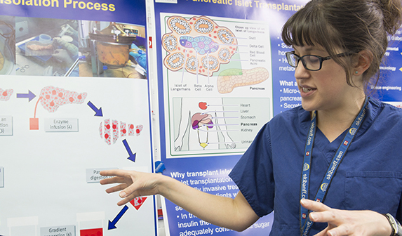
- establishing an open, supportive and family-friendly working culture
- supporting career progression through teaching programmes, performance reviews and mentoring.
- proactive communication of flexible working and parental leave policies
NDS actively promotes family-friendly policies to help foster a family-friendly working environment, including provision of family leave (including shared parental, carers and adoption leave), flexible/part-time working and scheduling meetings within core hours that are compatible with personal/family commitments.

The University’s childcare services support staff with Tax Free Childcare to help staff save tax and national insurance on childcare costs, and we offer information on nursery providers and a nursery fee Salary Sacrifice Scheme. Our partnership with playscheme providers helps to support families during school holidays and signpost staff to parenting, local authority and other organisations that help support families and parents.

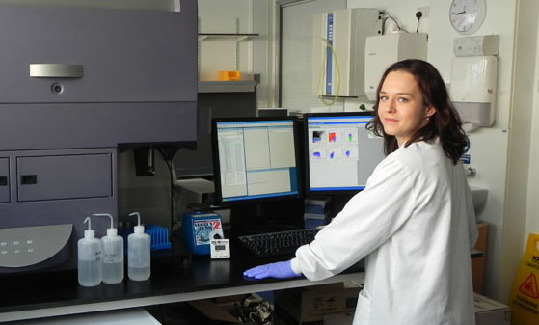
The Department is committed to ensuring that staff undertaking part-time or flexible working receive the same access to benefits and entitlements as full-time staff, including the same opportunities for training and promotion, a pro-rata entitlement to leave including bank holidays and careful consideration of requests to work part-time (particularly for those by staff returning from maternity leave).
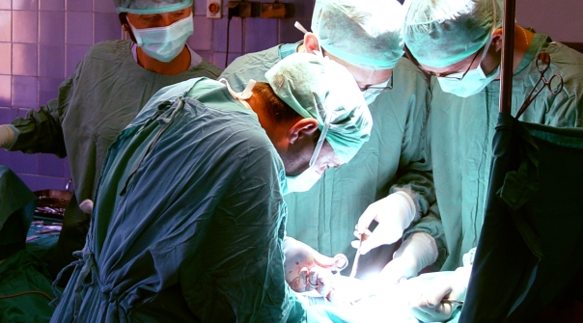
For more information please visit:
http://www.admin.ox.ac.uk/personnel/staffinfo/benefits/family/ and
http://www.admin.ox.ac.uk/personnel/during/flexible/

We work to uphold the University’s aim of providing an inclusive environment with equal career opportunities by promoting equality, valuing diversity and ensuring the rights and dignity of all staff are respected. Separate University policies are also in place to ensure race, disability and gender equality.

For more information, please visit:
http://www.admin.ox.ac.uk/eop/missionstatement/integratedequalitypolicy/

How to apply
Before submitting an application, you may find it helpful to read the ‘Tips on applying for a job at the University of Oxford’ document, at www.ox.ac.uk/about/jobs/supportandtechnical/.
If you would like to apply, click on the Apply Now button on the ‘Job Details’ page and follow the on-screen instructions to register as a new user or log-in if you have applied previously. Please provide details of two referees and indicate whether we can contact them now.

You will also be asked to upload a CV and a supporting statement. The supporting statement must explain how you meet each of the selection criteria for the post using examples of your skills and experience. This may include experience gained in employment, education, or during career breaks (such as time out to care for dependants).

Your application will be judged solely on the basis of how you demonstrate that you meet the selection criteria stated in the job description.

Please upload all documents as PDF files with your name and the document type in the filename.

All applications must be received by midday on the closing date stated in the online advertisement.

Information for priority candidates
A priority candidate is a University employee who is seeking redeployment because they have been advised that they are at risk of redundancy, or on grounds of ill-health/disability. Priority candidates are issued with a redeployment letter by their employing department(s).
If you are a priority candidate, please ensure that you attach your redeployment letter to your application (or email it to the contact address on the advert if the application form used for the vacancy does not allow attachments).

Should you experience any difficulties using the online application system, please email recruitment.support@admin.ox.ac.uk. Further help and support is available from www.ox.ac.uk/about_the_university/jobs/support/. To return to the online application at any stage, please go to: www.recruit.ox.ac.uk.

Please note that you will receive an automated email from our e-recruitment system to confirm receipt of your application. Please check your spam/junk mail if you do not receive this email.

Important information for candidates

Data Privacy
Please note that any personal data submitted to the University as part of the job application process will be processed in accordance with the GDPR and related UK data protection legislation. For further information, please see the University’s Privacy Notice for Job Applicants at: www.admin.ox.ac.uk/councilsec/compliance/gdpr/privacynotices/job/. The University’s Policy on Data Protection is available at: www.admin.ox.ac.uk/councilsec/compliance/gdpr/universitypolicyondataprotection/.

The University’s policy on retirement
The University operates an Employer Justified Retirement Age (EJRA) for all academic posts and some academic-related posts. The University has adopted an EJRA of 30 September before the 69th birthday for all academic and academic-related staff in posts at grade 8 and above. The justification for this is explained at: www.admin.ox.ac.uk/personnel/end/retirement/acrelretire8+/.

For existing employees, any employment beyond the retirement age is subject to approval through the procedures: www.admin.ox.ac.uk/personnel/end/retirement/acrelretire8+/.

There is no normal or fixed age at which staff in posts at grades 1–7 have to retire. Staff at these grades may elect to retire in accordance with the rules of the applicable pension scheme, as may be amended from time to time.

Equality of Opportunity
Entry into employment with the University and progression within employment will be determined only by personal merit and the application of criteria which are related to the duties of each particular post and the relevant salary structure. In all cases, ability to perform the job will be the primary consideration. No applicant or member of staff shall be discriminated against because of age, disability, gender reassignment, marriage or civil partnership, pregnancy or maternity, race, religion or belief, sex, or sexual orientation.
Benefits of working at the University

Employee benefits
University employees enjoy 38 days’ paid holiday, generous pension schemes, travel discounts, and a variety of professional development opportunities. Our range of other employee benefits and discounts also includes free entry to the Botanic Gardens and University colleges, and discounts at University museums. See www.admin.ox.ac.uk/personnel/staffinfo/benefits.

University Club and sports facilities
Membership of the University Club is free for all University staff. The University Club offers social, sporting, and hospitality facilities. Staff can also use the University Sports Centre on Iffley Road at discounted rates, including a fitness centre, powerlifting room, and swimming pool. See www.club.ox.ac.uk and www.sport.ox.ac.uk/oxford-university-sports-facilities.

Information for staff new to Oxford
If you are relocating to Oxfordshire from overseas or elsewhere in the UK, the University's Welcome Service website includes practical information about settling in the area, including advice on relocation, accommodation, and local schools. See www.welcome.ox.ac.uk.
There is also a visa loan scheme to cover the costs of UK visa applications for staff and their dependents. See www.admin.ox.ac.uk/personnel/permits/reimburse&loanscheme/.

Family-friendly benefits
With one of the most generous family leave schemes in the Higher Education sector, and a range of flexible working options, Oxford aims to be a family-friendly employer. We also subscribe to My Family Care, a service that provides practical advice and support for employees who have caring responsibilities. The service offers a free telephone advice line, and the ability to book emergency back-up care for children, adult dependents and elderly relatives. See www.admin.ox.ac.uk/personnel/staffinfo/benefits/family/mfc/.

Childcare
The University has excellent childcare services, including five University nurseries as well as University-supported places at many other private nurseries.
For full details, including how to apply and the costs, see www.admin.ox.ac.uk/childcare/.

Disabled staff
We are committed to supporting members of staff with disabilities or long-term health conditions. For further details, including information about how to make contact, in confidence, with the University’s Staff Disability Advisor, see www.admin.ox.ac.uk/eop/disab/staff.

Staff networks
The University has a number of staff networks including the Oxford Research Staff Society, BME staff network, LGBT+ staff network and a disabled staff network. You can find more information at www.admin.ox.ac.uk/eop/inpractice/networks/.

The University of Oxford Newcomers' Club
The University of Oxford Newcomers' Club is an organisation run by volunteers that aims to assist the partners of new staff settle into Oxford, and provides them with an opportunity to meet people and make connections in the local area. See www.newcomers.ox.ac.uk.

